ABNORMAL PSYCHOLOGY: Introductory understanding and its historical context

UNDERSTANDING ABNORMAL PSYCHOLOGY: DEFINITION OF TERMS

Abnormal Psychology - the branch of psychology devoted to the study, assessment, treatment, and prevention of maladaptive behavior.

Psychopathology - the scientific study of mental disorders, including their theoretical underpinning, etiology, progression, symptomatology, diagnosis, and treatment.

- This broad discipline draws on research from numerous areas, such as psychology, biochemistry, pharmacology, psychiatry, neurology, and endocrinology.
- The term psychopathology therefore is often synonymous with abnormal psychology.

Mental Disorders - also referred to as psychological disorders or problematic
abnormal behavior.

- It is important to note that “abnormal behavior” does not always connote a problematic (i.e., dysfunctional, distressing, and harmful) behavior.
  - That is, there are behaviors that are considered to be “abnormal” depending on one’s group or social norms.
  - For instance, a student might be considered sluggish or lazy, but it does not necessarily suggest a mental disorder.
  - Other terms that are interchangeable with psychological disorders: Mental Illness; Psychiatric Disorder; Psychiatric Illness.

FOUR Ds OF DEFINING PSYCHOLOGICAL DISORDER

In defining what is considered to be a “psychological disorder”, the following four criteria are needed to be met.
- Dysfunction - refers to a breakdown in cognitive, emotional, or behavioral functioning.
  - Dysfunction typically lasts a relatively short period of time as opposed to impairment. Although it helps to understand dysfunction might precede impairment.

- Distress - a state of being extremely upset.
  - Often contingent to distress (and other criteria) is impairment or the incapability to perform relatively easy tasks or behavior.

- Deviance - also referred to as atypical or not culturally expected. It is the deviation of behavior from the “average”or “norm”; the greater the deviation, the more abnormal it is.
  - At times, something is considered abnormal because it occurs infrequently, or inconsistent to one’s or social behavior.

- Danger to oneself or others - also referred to as harmful dysfunction. This is a tendency that a behavior being produced can harm or be an adverse effect to the individual itself or to the people around.

THE SCIENTIST-PRACTITIONER MODEL

Many mental health professionals take a scientific approach to their clinical work, and therefore are called scientist practitioners.

A functioning scientist-practitioner can be either in one or more ways:
- Consumer of Science - they keep up with the latest scientific developments in their field and therefore use the most current diagnostic and treatment procedures.
- Evaluator of Science - they determine the effectiveness of their assessments and treatment procedures.
- Creator of Science - they conduct research themselves that leads to new procedures useful in practice.

CLINICAL DESCRIPTION

Represents the unique combination of behavior, thoughts, and feelings that make up a specific behavior.
- The term clinical here, refers to both the types of problems or disorders that you would find in a clinic or hospital and to the activities connected with assessment and treatment.
- In determining the first stem of a clinical description, the assessor needs to know why the patient comes to the clinic. This is referred to as a presenting problem.
  - Presenting Problem - a traditional shorthand way of indicating why the person came to the clinic. Also referred to as presents (e.g., “the patient presents mild headache”).

STATISTICS-RELATED TERMS RELEVANT TO CLINICAL DESCRIPTION

Prevalence - asks the question: how many people in the population as a whole have the disorder?
Incidence - asks the question: how many people new cases occur during a given period or time, such as weeks, months, or years?

- Prevalence = number of cases
- Incidence = number of times
It is important to note that the context of prevalence and incidence is always accompanied by statistical data.
- And beside prevalence and incidence there are other statistical description relevant to clinical descriptions such as:
  - Sex ratio - determines what percentage of males and females have the disorder.
  - Age of onset - determines which age often differs from one disorder to another.

OTHER TERMS RELEVANT TO CLINICAL DESCRIPTION

In addition to the relevance of statistical description, the pattern of the disorder, when did the disorder begin, and what should be anticipated, are important in clinical description.

- Course - refers to the individual pattern of a particular disorder. It is categorized into three:
  - Chronic Course - meaning the disorder tends to last a long time, sometimes a lifetime.
  - Episodic Course - meaning the disorder is likely recoverable within the span of few months, however, recurs at a later time.
  - Time-limited Course - meaning the disorder will improve without treatment in a relatively short period with little or no risk of recurrence.

- Onset - refers to how fast the disorder is obtained or begins. Categorized into two:
  - Acute Onset - means the disorder begins suddenly.
  - Insidious - means the disorder being gradually over an extended period.

- Prognosis - refers to the anticipated course of a disorder.
  - “the prognosis is good” - means the individual will probably recover.
  - “the prognosis is guarded” - means the probable outcome does not look good.

HISTORICAL VIEWS OF ABNORMAL BEHAVIOR
The Supernatural Tradition; The Biological Tradition; The Psychological Tradition;
The Present

THE SUPERNATURAL TRADITIONS:

Witchcraft and Demonology

- In this tradition, individuals suffering from mental disorders are deemed to be possessed and controlled by magic, evil spirits, and demons.
Treatments:
- Exorcism – in which various religious rituals were performed in an effort to rid the victim of evil spirits.
- Punishments – such as chaining individuals with mental disorders, keeping them in cases, or horrible rituals of boring a hole in the skull.

Stress and Melancholy

- During this time, the proposition of witchcraft and demons as caused by mental disorders was challenged by the idea that mental disorders are caused by emotional stress and were curable.
- Stress and melancholy (depression) was seen as the sources of mental disorders.
- Despite this rational proposition, however, the church deemed mental disorders as divine retribution. That is, despair and lethargy were often identified by the sins of Acadia or sloth.

Treatments:
- Rest, sleep, healthy environment, baths, ointments, potions.
- People with insanity, along with those with physical deformities or disabilities were often moved from house to house in medieval villages as neighbors took turns caring for them.

The origin of Mass Hysteria

- Mass hysteria is a large-scale outbreak of bizarre behavior.
  - Mass hysteria is believed to be due to emotion contagion, or the tendency of people to be suggestible during heightened emotional experience.
  - Mass hysteria is colloquially known as mob psychology

A psychological phenomenon occurred in this tradition is mass hysteria. In Europe, during what is known today as the Saint Vitus’s Dance, Tarantism, groups of people were simultaneously compelled to run out in the streets, dance, shout, rave, and jump around in patterns as if they were at a particularly wild party.

Moons and Stars; Astrology

Paracelsus (1493 – 11541) a swiss physician rejected the notion of possession by the devil, suggesting instead that the movements of the moon and stars had effects on people’s psychological functioning.
- In this proposition, the word Lunatic originated from. That is, “luna” is derived from the Latin word “moon”.
- This was also deemed the be the birth of Astrology or the belief that the alignment of planets, stars, and cosmic entities are somehow related to our personality and behavior.

THE BIOLOGICAL TRADITIONS:

Galen

Galen (approx. AD 129 – 198)
- A Roman Physician adopted the ideas of Hippocrates and developed them further, and became the Hippocratic-Galenic Approach
- In this approach Galen came-up with Humoral Theory of Disorder, which posits the normal brain functioning was related to four bodily fluids that are called humors and were associated with personality traits.

Four Bodily Fluids:
- Blood – from the heart; which is associated with the personality sanguine
  - A sanguine person is described as someone who is ruddy in complexion, cheerfulness, and optimistic.
- Black Bile – from the spleen; which is associated with the personality melancholy.
  - A melancholic person is described as moody, anxious, quiet, or reserved.
- Phlegm – from the brain; which is associated with the personality phlegmatic.
  - A phlegmatic person is described as passive, careful, calm, controlled, and even-tempered.
- Choler/Yellow Bile – from the liver; which is associated with the personality choleric.
  - A choleric person is described as restless, aggressive, excitable, and active.

The four humors were also related to the Greek’s conception of the four basic qualities which include heat, dryness, moisture, and cold.
- Excess humors were treated by regulating the environment to increase or decrease heat, dryness, moisture, or cold; depending on which humor was out of balance.
Treatments:
- Rest, good nutrition, and exercise
- Bloodletting
- Induced vomiting

The origin of Hysteria

Hysteria
- An exaggerated or uncontrollable emotions or excitement.
- Hysteria, in this tradition, was deemed as due to “wandering womb or uterus'” and as many hysteria cases observed were primarily women.
- Hippocrates coined the term, which is derived from the Greek word “hysteron” which translates to “uterus”.
- Prescribe Cure: Marriage; Fumigation of the Vagina
- Hysteria is classified today as Somatic Symptom Disorders and is not limited to women.

Similar concepts of Humoral Theory

- Ancient China and Through Asia
  - Chinese focus on the movement of air or “wind” throughout the body; yin and yang.
  - Unexplained mental disorders were caused by blockages of wind, or the present of cold, dark wind (yin) as opposed to warm, life sustaining wind (yang).
Treatment:
- Acupuncture: A Chinese medicine in which thin needles are inserted to the body.
- It is believed to restore flow of wind.

The 19th Century

Discovery of the Nature and Cause of Syphilis

Syphilis
- A sexually transmitted disease caused by a bacterial microorganism entering the brain, which typically precedes delusion of persecution and delusion of grandeur.
  - Delusion of Persecution – believing that everyone plotting against you
  - Delusion of Grandeur - believing that you are god.
- Symptoms of syphilis resemble psychosis, psychological disorders characterized in part by beliefs that are not based in reality (delusions), perceptions that are not based in reality (hallucination), or both.

General Paresis (1892) along with Germ Theory

Louis Pasteur’s Germ Theory of Disease (1870) facilitated the identification of the microorganism that caused syphilis.
- Cure for General Paresis:
  - Physicians observed a surprising recovery in patients with general paresis who had contracted malaria
  - Investigators discovered that penicillin cured syphilis.
  - With the malaria cue,“madness” and associated symptoms for the first time were traced directly to a curable infection.
John P. Grey
- An influential American Psychiatrist
- Superintendent of the Utica State Hospital in New York (1854)
- Editor of the journal American Journal of Insanity (which is now American Journal of Psychiatry).
- Held that causes of insanity were physical and should be treated like one:
- Grey advocated for the following treatments:
  - Rest, diet, and proper room temperature and ventilation.
  - Grey even invented the rotary fan to ventilate his hospital.
  - Conditions in hospitals improved and they became more humane institutions.
  - Ironically, due to the increased number of patients in the institution, the government ordered that some patients needed to be deinstitutionalized.

The 20th Century

Early 20th Century

Joseph von Meduna (1920s)
- Observed that schizophrenia was rarely found in individuals with epilepsy.
- His followers concluded that induced brain seizures might cure schizophrenia.
  - Treatment: Applying electric shock directly to the brain, referred to as Electroconvulsive Therapy.

Manfred Sakel (1930s)
- Began insulin using increasingly higher dosages until patients convulsed and became temporarily comatose. Although some recovered, many did not.
  - Insulin – a chemical that stops sugar production of the body,
  - It was used to stimulate appetite in psychotic patients, which also seemed to calm them down.
  - Sakel’s treatment method became known as Insulin Shock Therapy.

Mid and Late 20th Century

- Opium used as sedatives (i.e., it was used to calm and induce sleep)
- With the discovery of Rauwolfia Serpentine (later renamed reserpine) and neuroleptics (major tranquilizers ), for the first time hallucinatory and delusional thought processes could be diminished in some patients; these drugs also controlled agitation and aggressiveness.
- Benzodiazepines - are minor tranquilizers, which seem to reduce anxiety. By the 1970s, the Valium and Librium (a form of benzodiazepines) were among the most widely prescribed drugs in the world.

THE PSYCHOLOGICAL TRADITION:

The 19th Century

Moral Therapy
- In the context of moral therapy, the word ‘Moral’ is referring more to emotional or psychological factors rather than to a code of conduct.
- The basic assumptions of moral therapy is treating institutionalized patients as normally as possible in a setting that encourages normal social interaction.
- Moral therapy as a system originated with French psychiatrist Philippe Pinel and his associate Jean-Bastiste Pussin.
- This was followed by William Tuke in England; Benjamin Rush and subsequently followed by Horace Mann in United States

Mid 19th Century

Decline of Moral Therapy
- Due to the aftermath of the American Civil War, many individuals suffered from traumatic experiences often leading to psychiatric illness.
- This increased to the number of patients in mental institutions, where it was poorly handled by deinstitutionalizing many patients despite psychiatric assistance.
Dorothea Dix,
- the proponent of the Mental Hygiene Movement.
- Advocated for the reform of how patients with mental illness are being treated.
- However, her advocacy declined when the mental practitioners themselves concluded “mental illness was caused by brain pathology, and therefore, was incurable”.

Psychoanalytic Theory

- Franz Anton Mesmer (1734–1815):
  - Animal Magnetism
- Jean Martin Charcot
  - Legitimized practice of hypnotism
  - A mentor of Freud.
- Sigmund Freud
  - Came from Vienna to study with Charcot in Paris.
  - Teamed up with Josef Breuer to treat the patient named Anna O.
Freud and Breuer
- Along with this, they discovered a therapeutic technique called free association.
- Free association, a therapeutic technique which asks the patient to recall and relive emotional trauma that has been made unconscious and to release the accompanying tension.
  - Catharsis – the release of emotional material
  - Insights – fuller understanding of the relationship between current emotions and earlier events.
Freud expanded the observation they got from Anna O. The expansion of ideas later became the psychoanalytic model or theory.
Which posits three assumptions:
- The structure of the mind and the functions of personality often clash with one another and create intrapsychic conflicts.
- There are defense mechanisms with which the mind defends itself from these conflicts;
- The stages of psychosexual development that contribute to our inner conflicts.

Humanistic Theory

Self-actualization
- A construct in humanistic theory, where it presumes that all of us could reach our highest potential if we had the freedom to grow.
Proponents of Humanistic Theory:
- Abraham Maslow (Holistic-Psychodynamic Theory)
- Carl Rogers (Person-Centered Theory)
  - Unconditional Positive Regard – the complete acceptance of most of the client’s feelings and actions, is critical to the humanistic approach.
  - Empathy – is the understanding of the individual’s view of the word; “putting someone else’s shoes”
  - Client-Centered – the therapeutic technique
Maslow’s Hierarchy of Needs
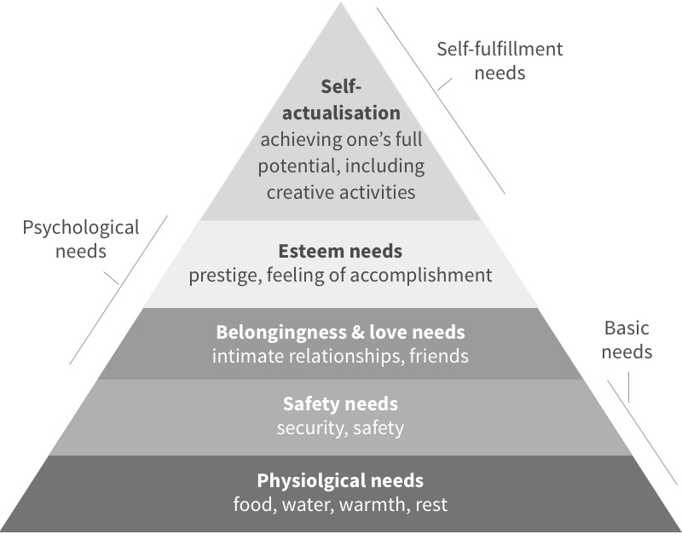

Behavioral Model
- Ivan Pavlov: Initiated the study of classical conditioning.
- John B. Watson: Founder of Behaviorism and famously known for his Little Albert Experiment.
- Joseph Wolpe: Introduce the idea of Systematic Desensitization
  - Systematic Desensitization - Individuals were gradually introduced to the objects or situations they feared so their fear could extinguish. Also referred today as exposure therapy
B.F. Skinner
- Operant Conditioning – behavior changes as a function of what follows the behavior.
  - Reinforcement v. Punishment
  - Shaping – a process of reinforcing successive approximations to final behavior or set of behaviors.

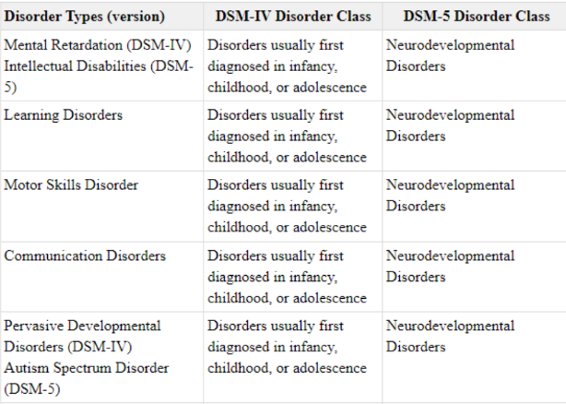
DISORDERS USUALLY FIRST DIAGNOSED IN INFANCY, CHILDHOOD OR ADOLESCENCE

